Министерство образования Республики Беларусь
Учреждение образования
«Брестский Государственный технический университет»
Кафедра ИИТ

Лабораторная работа №3
По дисциплине «Модели решения задач в интеллектуальных системах»
Тема: «Рекуррентные нейронные сети»

Выполнил:
Студент 3 курса
Группы ИИ-23
Макаревич н.Р.
Проверил:
Туз И. С.

Брест 2025

Цель: Реализовать и обучить рекуррентную нейронную сеть 4 способами.
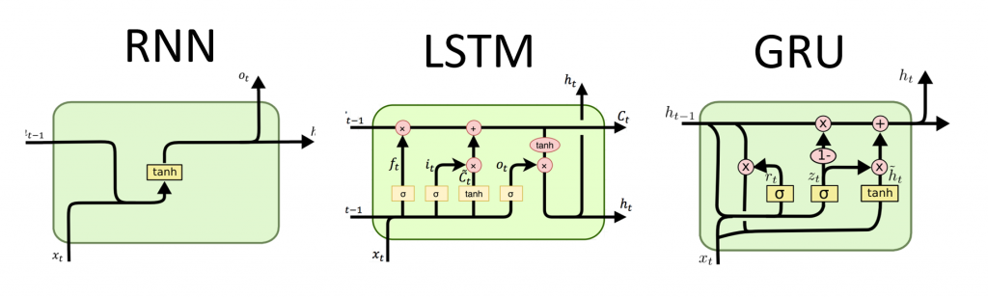
Recurrent.py
def generate_data():
x = np.linspace(0, 10, 100)
y = np.cos(4 * x) + 2 * np.sin(3 * x)
return x, y

def create_sequences(data, seq_length):
xs, ys = [], []
for i in range(len(data) - seq_length):
x = data[i:(i + seq_length)]
y = data[i + seq_length]
xs.append(x)
ys.append(y)
return np.array(xs), np.array(ys)

SEQ_LENGTH = 5
HIDDEN_SIZE = 32
EPOCHS = 200
BATCH_SIZE = 8
LEARNING_RATE = 0.01
x, y = generate_data()
X, Y = create_sequences(y, SEQ_LENGTH)
X = X.reshape(-1, SEQ_LENGTH, 1)
Y = Y.reshape(-1, 1)
X_train, X_test, Y_train, Y_test = train_test_split(X, Y, test_size=0.2, shuffle=False)
X_train = torch.FloatTensor(X_train)
Y_train = torch.FloatTensor(Y_train)
X_test = torch.FloatTensor(X_test)
Y_test = torch.FloatTensor(Y_test)
train_data = TensorDataset(X_train, Y_train)
train_loader = DataLoader(train_data, batch_size=BATCH_SIZE, shuffle=False)

class SimpleRNN(nn.Module):
def __init__(self, input_size, hidden_size, output_size):
super().__init__()
self.hidden_size = hidden_size
self.W = nn.Parameter(torch.randn(input_size + hidden_size, hidden_size) * 0.01)
self.W_out = nn.Parameter(torch.randn(hidden_size, output_size) * 0.01)
self.b = nn.Parameter(torch.zeros(hidden_size))
self.b_out = nn.Parameter(torch.zeros(output_size))

def forward(self, x):
device = x.device
batch_size = x.size(0)
h = torch.zeros(batch_size, self.hidden_size).to(device)
for t in range(x.size(1)):
combined = torch.cat((x[:, t, :], h), dim=1)
h = torch.tanh(combined @ self.W + self.b)
return h @ self.W_out + self.b_out

class PyTorchRNN(nn.Module):
def __init__(self, input_size, hidden_size, output_size):
super(PyTorchRNN, self).__init__()
self.rnn = nn.RNN(input_size, hidden_size, batch_first=True)
self.fc = nn.Linear(hidden_size, output_size)

def forward(self, x):
out, _ = self.rnn(x)
out = self.fc(out[:, -1, :])
return out

class GRUModel(nn.Module):
def __init__(self, input_size, hidden_size, output_size):
super(GRUModel, self).__init__()
self.gru = nn.GRU(input_size, hidden_size, batch_first=True)
self.fc = nn.Linear(hidden_size, output_size)

def forward(self, x):
out, _ = self.gru(x)
out = self.fc(out[:, -1, :])
return out

class LSTMModel(nn.Module):
def __init__(self, input_size, hidden_size, output_size):
super(LSTMModel, self).__init__()
self.lstm = nn.LSTM(input_size, hidden_size, batch_first=True)
self.fc = nn.Linear(hidden_size, output_size)

def forward(self, x):
out, _ = self.lstm(x)
out = self.fc(out[:, -1, :])
return out

def train_model(model, train_loader, criterion, optimizer, epochs):
train_loss = []
test_loss = []

for epoch in range(epochs):
model.train()
total_loss = 0

for batch_x, batch_y in train_loader:
optimizer.zero_grad()
output = model(batch_x)
loss = criterion(output, batch_y)
loss.backward()
optimizer.step()
total_loss += loss.item()

avg_train_loss = total_loss / len(train_loader)
train_loss.append(avg_train_loss)

# Оценка на тестовых данных
model.eval()
with torch.no_grad():
test_output = model(X_test)
test_loss_val = criterion(test_output, Y_test).item()
test_loss.append(test_loss_val)

if (epoch + 1) % 50 == 0:
print(f'Epoch {epoch + 1}, Train Loss: {avg_train_loss:.4f}, Test Loss: {test_loss_val:.4f}')

return train_loss, test_loss

manual_rnn = SimpleRNN(1, HIDDEN_SIZE, 1)
pytorch_rnn = PyTorchRNN(1, HIDDEN_SIZE, 1)
gru = GRUModel(1, HIDDEN_SIZE, 1)
lstm = LSTMModel(1, HIDDEN_SIZE, 1)

criterion = nn.MSELoss()
manual_optimizer = torch.optim.Adam(manual_rnn.parameters(), lr=LEARNING_RATE)
rnn_optimizer = torch.optim.Adam(pytorch_rnn.parameters(), lr=LEARNING_RATE)
gru_optimizer = torch.optim.Adam(gru.parameters(), lr=LEARNING_RATE)
lstm_optimizer = torch.optim.Adam(lstm.parameters(), lr=LEARNING_RATE)

print("Training Manual RNN...")
manual_train_loss, manual_test_loss = train_model(manual_rnn, train_loader, criterion, manual_optimizer, EPOCHS)

print("\nTraining PyTorch RNN...")
rnn_train_loss, rnn_test_loss = train_model(pytorch_rnn, train_loader, criterion, rnn_optimizer, EPOCHS)

print("\nTraining GRU...")
gru_train_loss, gru_test_loss = train_model(gru, train_loader, criterion, gru_optimizer, EPOCHS)

print("\nTraining LSTM...")
lstm_train_loss, lstm_test_loss = train_model(lstm, train_loader, criterion, lstm_optimizer, EPOCHS)

def predict(model, X):
model.eval()
with torch.no_grad():
predictions = model(X)
return predictions.numpy()

manual_pred = predict(manual_rnn, X_test)
rnn_pred = predict(pytorch_rnn, X_test)
gru_pred = predict(gru, X_test)
lstm_pred = predict(lstm, X_test)
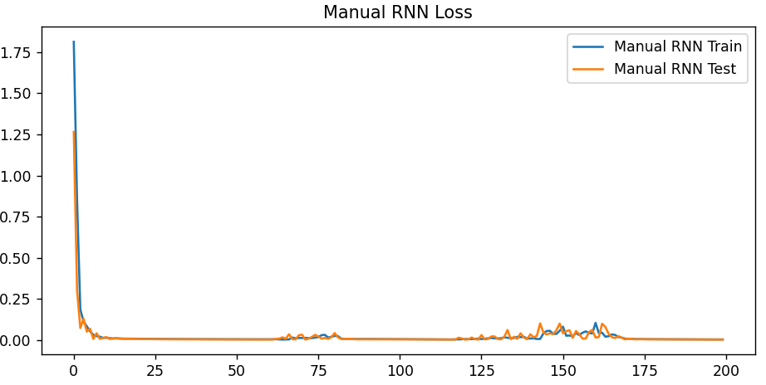
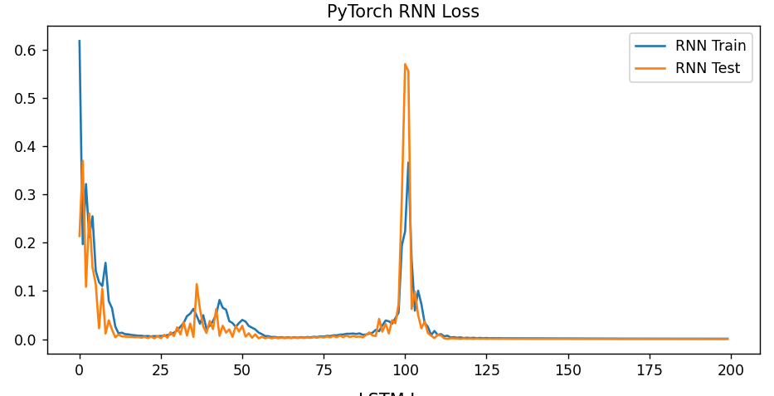
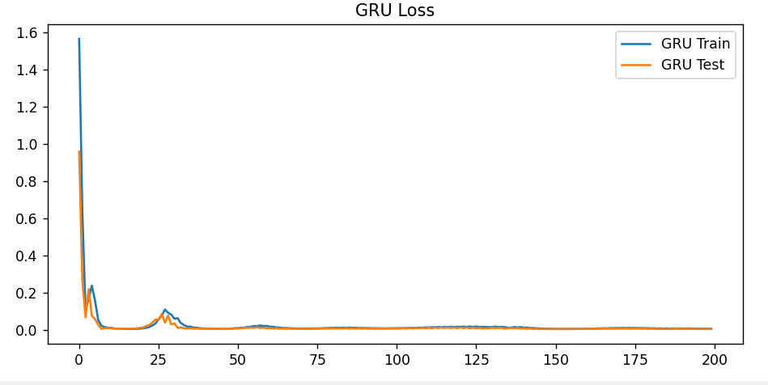
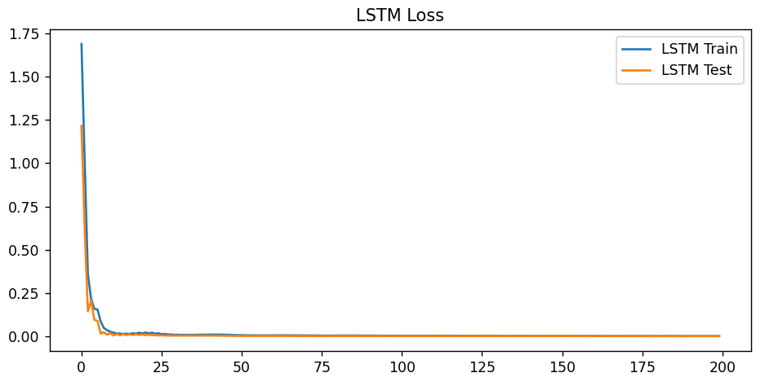

Вывод: реализовал и обучил автоэнкодер

